Testing Resport 03/05-05/05

Memory

I had added more recordings to the ones I was using for my models (from the panoptic studio dataset) -I am not using all of them yet-, and I found out that some of the new additions had some invalid frames at the end of them that generated padding the way I processed them. I fixed that and I started to run tests. I used 20 videos for training, 8 for validation and 8 for testing.

My architecture consists in a LSTM with N-layers followed by a fully connected layer with ReLU activation. I run tests on three different variations of this architecture:
- “Small”- 2 layer LSTM with hidden size 512 ( 3,273,754 trainable parameters).
- “Medium”- 2 layer bidirectional LSTM with hidden size 512 ( 8,644,634 trainable parameters).
- “Large”- 2 layer bidirectional LSTM with hidden size 1024 ( 34,066,458 trainable parameters).

Since I wasn’t getting any results I decided to first try to overfit the models to the training data and then apply some regularization methods to prevent overfitting: dropout, weight decay and apply a schedule to the learning rate following the 1-cycle policy. As you will see the results aren’t good, but I will discuss them on the sections below. For the “large” architecture I couldn’t get it to learn appropriately so I didn’t put the results.

Results
For every model in every section, I will put the results with the following format: first, on the left there will be the training and validation loss over the epochs and on the right the number of zero frames in each video prediction for training data; below, there will be the number of zero frames for validation data and after that, the test loss and test MPJPE; finally, I will plot a sample predicted skeleton against the groundtruth.

Body keypoints estimation

Small
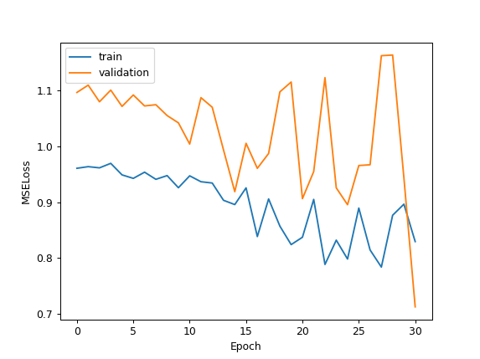
Zero frames / Total frames:
1: 2496/8751
2: 2209/7836
3: 3785/8045
4: 4118/8752
5: 4098/8751
6: 2442/5155
7: 1/8272
8: 1/7326
9: 0/6012
10: 0/7141
11: 4058/8751
12: 4058/8751
13: 1502/8272
14: 934/5176
15: 2/6012
16: 2/8272
17: 0/8272
18: 0/8752
19: 0/5952
20: 0/8751
Zero frames / Total frames(Valid):
1438/5155
1444/5176
3354/7141
3439/7326
2811/5952
5861/8574
1/7611
1249/8574
Test:
MPJPE: 0.0625 Test loss: 1.0686

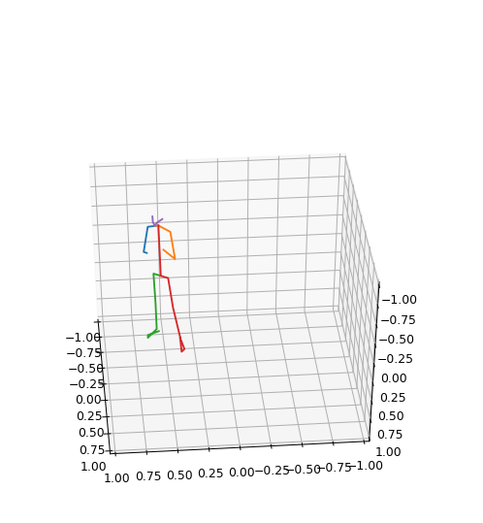
Training plots [predicted | groundtruth]

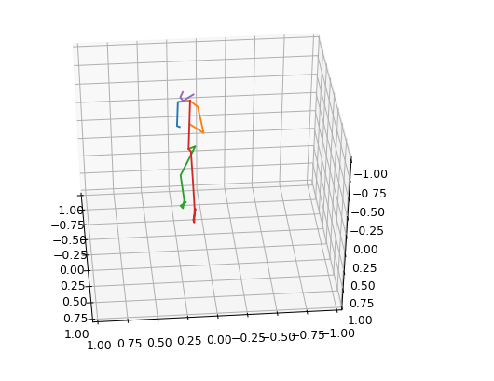

Medium
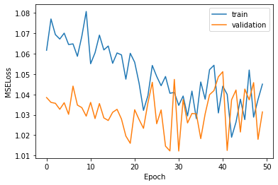
Zero frames / Total frames:
0/5176
0/8751
0/7141
0/7141
0/8574
0/8574
0/7611
0/8751
0/6953
0/8272
0/5952
0/8751
0/7611
0/5155
0/8272
0/8751
0/7326
0/5155
0/6012
0/8751
Zero frames / Total frames(Valid):
2869/8045
0/8271
1131/8272
0/6953
0/8272
0/7836
225/7836
0/6012

Test:
MPJPE: 0.0486 Test loss: 0.8034

Training plots [predicted | groundtruth]
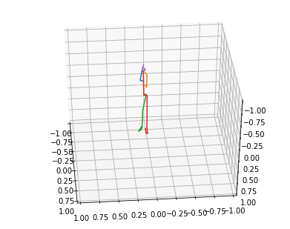
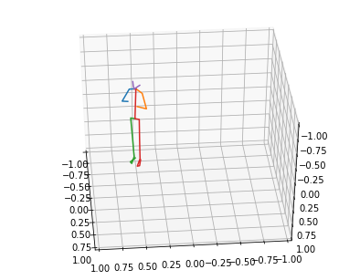

Hands keypoints estimation

Small
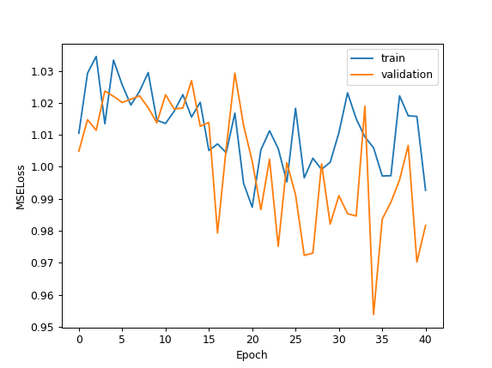
Zero frames / Total frames:
2136/8751
1999/8272
0/6012
0/5176
0/5952
0/8751
2128/8575
2172/8752
10/5952
11/6953
0/8575
0/8751
1919/8272
1900/8045
0/8272
0/7326
0/8271
0/7836
1000/5155
1487/7141
Zero frames / Total frames(Valid):
1738/7326
2478/8751
0/5155
2435/7611
1001/6953
1/8752
1993/8045
1884/7611

Test:
MPJPE: 0.0243 Test loss: 0.9396

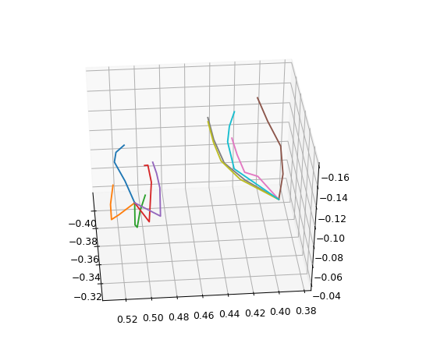
Training plots [predicted | groundtruth]
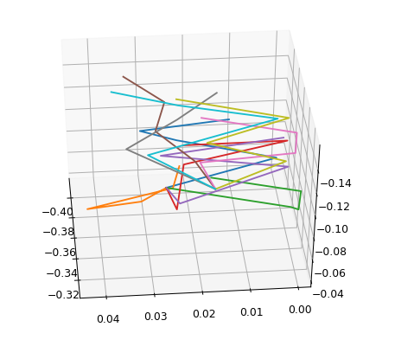

Medium
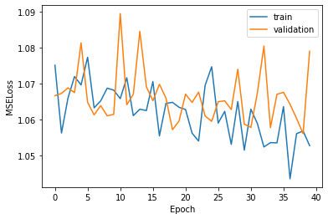
Zero frames / Total frames:
0/8272
0/8752
0/5952
0/8272
0/6012
0/8045
0/8272
0/7141
0/7611
0/8751
0/7836
0/8271
0/8271
0/7611
0/5155
0/5952
0/8751
0/8575
0/8751
0/8751
Zero frames / Total frames(Valid.):
0/5155
0/6012
0/5176
0/6953
2260/8272
0/7326
0/8045
0/5176

Test:
MPJPE: 0.0266 Test loss: 0.7840

Training plots [predicted | groundtruth]
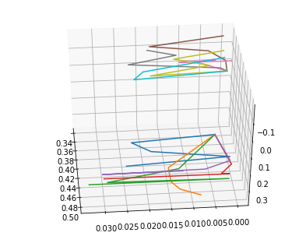
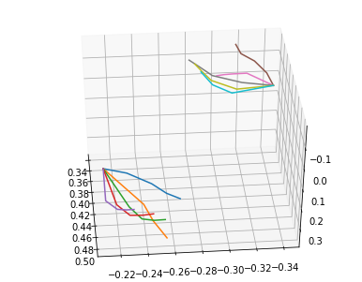

Face keypoints estimation

Small
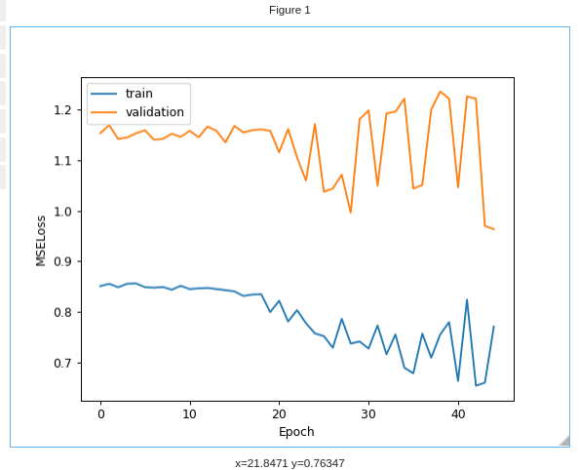
Zero frames / Total frames:
0/8272
0/7326
3878/8752
3562/8045
2265/6953
2506/8575
3584/8045
3684/8272
2/8751
2/8271
6900/7836
4563/5155
1/5155
1/7141
3748/8751
3749/8752
3285/7611
3285/7611
3199/7326
3837/8751
Zero frames / Total frames(Valid.):
0/8272
0/6953
2637/5952
2662/6012
1965/6012
2682/8751
3183/7141
2665/5952

Test:
MPJPE: 0.0258 Test loss: 1.3394

Training plots [predicted | groundtruth]
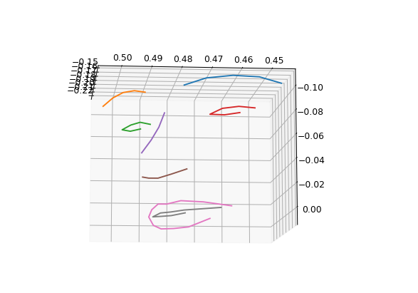
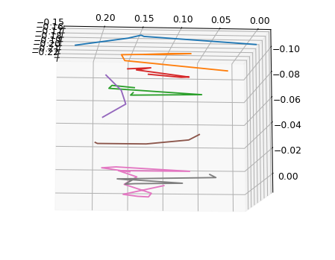

Medium
Similar to previous

Analysis
As you can see, the results are quite bad. The losses get really noisy, though they have a decreasing tendency. I didn’t show the results of the “Large” architecture because I couldn’t make the training loss decrease. More capacity doesn’t seem to improve the results as it is now.
Also, these are some of the best results I could get, but every time I load the keypoints I shuffle them randomly, and I noticed that without changing parameters it differed a lot from a run to another. Then, there is a high variance on the data I am using.

Difficulties
The project is much more time consuming than I expected. Since I am not getting results, I have to test over and over changing some parameters and it takes ~30 s to train an epoch if I train for 40-60 epochs, that makes 20-30 min each run. Although I use 2-3 computer simultaneously, it is still a slow process.
Furthermore, I am not using the full dataset because it takes too much time to download a new recording, copy it to my working directory, remove the blank frames and load it to my runtime.
I have been working as much as I planned and more, but it is taking me much longer than expected to get good results, so I don’t know whether I will be able to accomplish the objective with good performance.

Conclusions
- I need to use more data to increase the batch size to reduce the noise and variance. Since I have few videos but each has a lot of frames, I thought of splitting each video in, for example, 4 parts and take them as a video each. I was avoiding to do that, because I could lose temporal information of the sequence, but I think it’s worth giving it a try. Of course, I will also add a couple of recordings more (but it’s still too much time consuming).
- Network still have some tendency to predict zero, despite knowing when there is padding on the input and where.
- I want to try other solutions, such thinking about the problem as a classification task (currently working on it), or try a transformer (encoder-decoder) architecture. But since the final report due date is 18th May I won’t have time to try much.

